**Project Design Phase**

**Solution Architecture**

|  |  |
| --- | --- |
| Date | 28 June 2025 |
| Team ID | LTVIP2025TMID35938 |
| Project Name | Revolutionizing Liver Care : Predicting Liver Cirrhosis using Advanced Machine Learning Techniques |
| Maximum Marks | 4 Marks |

**Solution Architecture:**

**🔹 Step 1: Data Collection & Preprocessing**

* Collect clinical data (e.g., bilirubin, albumin, INR, etc.) from the UCI Liver Cirrhosis dataset.
* Clean the data, handle missing values, encode categorical fields, and scale numeric features.

**🔹 Step 2: Model Training**

* Train an **XGBoost classifier** on the processed data.
* Evaluate model performance using metrics like accuracy and ROC-AUC.
* Save the trained model and scaler for later use (serialization with joblib or pickle).

**🔹 Step 3: Backend Development (Flask)**

* Use **Flask** to build a backend API.
* The API receives user input, preprocesses it, loads the trained model, and returns the prediction and confidence score.

**🔹 Step 4: Frontend Development**

* Design a clean web interface using **HTML, CSS, and Bootstrap**.
* Include pages for: Home, Prediction Form, Dashboard, and About.
* Display the prediction results clearly with visual indicators (e.g., risk levels: Low/Medium/High).

**🔹 Step 5: Deployment & Access**

* Deploy the full app on a platform like **Render** or **Heroku**.
* Make the system accessible via web browser for doctors and patients.
* Plan for future scalability (e.g., mobile app, cloud support).

**Flow chart:**

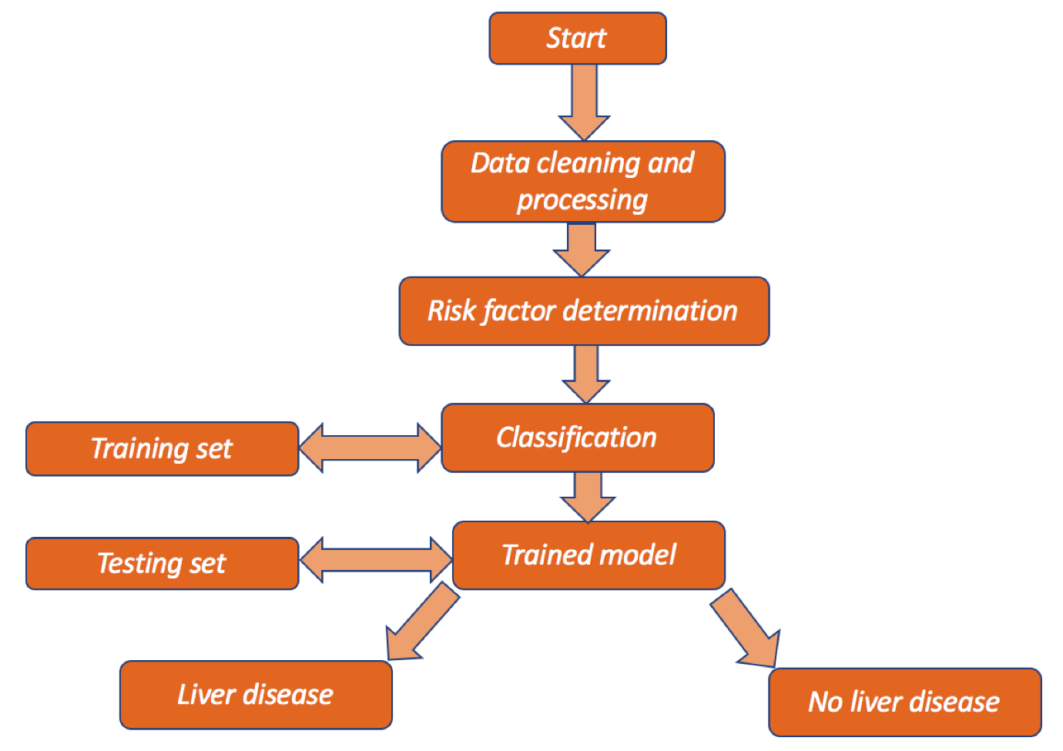

**Example - Solution Architecture Diagram:**

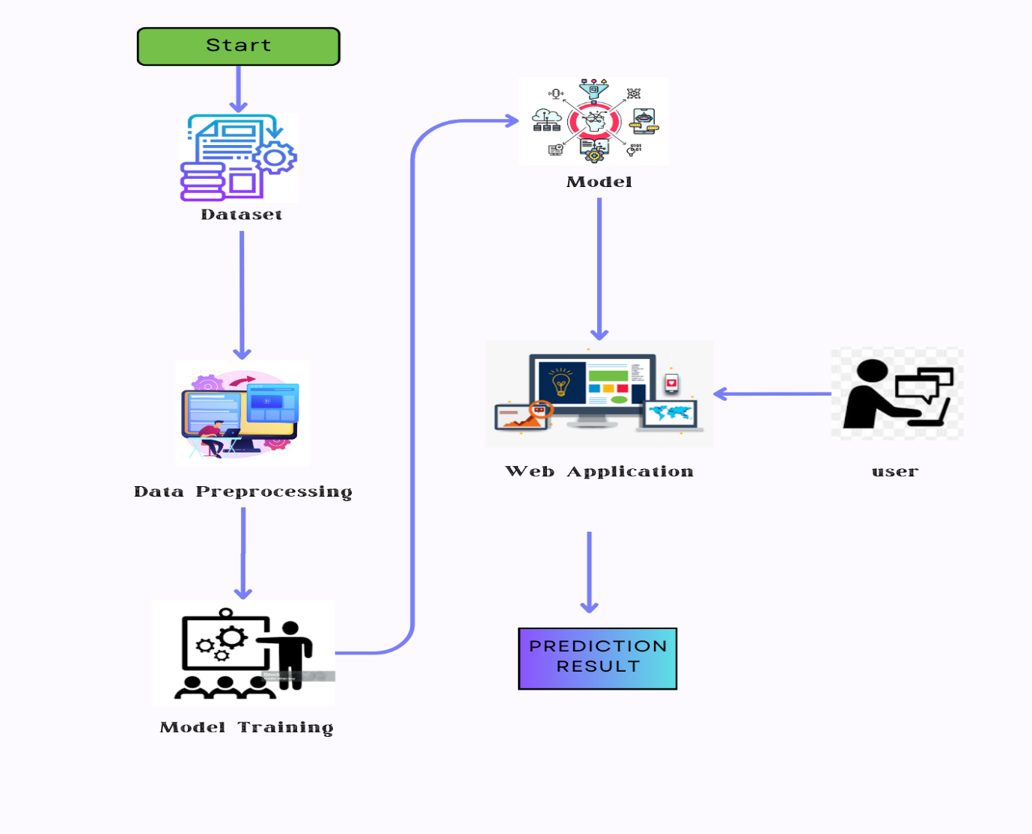

**References:**

1. <https://www.google.com/url?sa=i&url=https%3A%2F%2Fwww.researchgate.net%2Ffigure%2FWorkflow-of-the-liver-disease-prediction-model_fig1_369380842&psig=AOvVaw255uvtPVjm5N5kWsIfDGE7&ust=1751041737211000&source=images&cd=vfe&opi=89978449&ved=0CBQQjRxqFwoTCOiP0vnAj44DFQAAAAAdAAAAABAe>
2. [**https://youtu.be/GoY6xFlcg4o**](https://youtu.be/GoY6xFlcg4o)
3. [**https://www.google.com/url?sa=i&url=https%3A%2F%2Fwww.youtube.com%2Fwatch%3Fv%3DCI928ModPRs&psig=AOvVaw3NTgRY9CSavGR29FD5_5jc&ust=1751041983864000&source=images&cd=vfe&opi=89978449&ved=0CBQQjRxqFwoTCMi6_u3Bj44DFQAAAAAdAAAAABAW**](https://www.google.com/url?sa=i&url=https%3A%2F%2Fwww.youtube.com%2Fwatch%3Fv%3DCI928ModPRs&psig=AOvVaw3NTgRY9CSavGR29FD5_5jc&ust=1751041983864000&source=images&cd=vfe&opi=89978449&ved=0CBQQjRxqFwoTCMi6_u3Bj44DFQAAAAAdAAAAABAW)